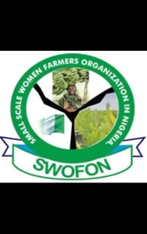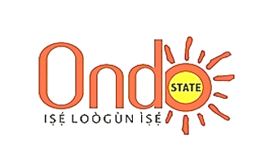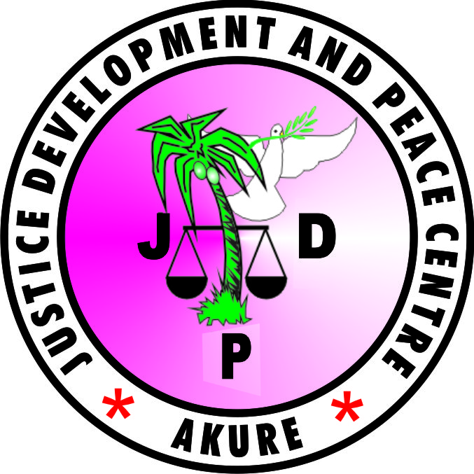

ONDO BCG

**COMMUNIQUE**

**Preamble**

*ActionAid (AAN), Justice Development and Peace Centre (JDPC), Budget Committee Group (BGC), Smallholder Women Farmers Organization of Nigeria (SWOFON), Ondo State chapter organized a 1-day Stakeholders Consultative Meeting for Ondo State on the 2025 Agriculture Budget held at Sunview Hotel, Alagbaka, Akure, Thursday 19th September, 2024*

Stakeholders Consultative Meeting for Ondo State on the 2025 Agriculture Budget was aimed at presenting the analysis and performance of the Ondo state 2024 Agriculture budget and leveraging participants understanding on the Ten (10) pillars of the National Agricultural Technology and Innovation Policy (NATIP) to promote sustainable agriculture practices for the state. The meeting additionally strengthened citizens’ participation and inputs towards making Ondo state 2025 Agriculture budget responsive towards food systems transformation and wealth creation.

It provided stakeholders the opportunity especially smallholder women farmers to participate in agriculture policy and budget formulation processes resulting to changes in priority budget line items that are pro-poor and even in the approach of government’s implementation of programmes and projects.

A total number of 33 participants attended. The participants included Special Adviser to the Governor on Gender, Ondo State Budget Office, the Federal Ministry of Agriculture and Food Security (FMAFS), Permanent Secretary Ondo State Ministry of Agriculture, Office of the Rural Access and Agricultural Marketing Project (RAAMP), Office of the Agriculture Input and Supply Agency (AISA), Small and Medium Enterprises Development Agency of Nigeria (SMEDAN) Ondo State Office, Agriculture and Development Project (ADP), Civil Society Organizations

**COMMENDATIONS**

* The organizers commend the Government Ministries, Departments and Agencies (MDAs) for remaining committed to collaborating with Non-State Actors. Such collaboration improves the civic space, build synergy – allowing for new relationships, and practical, innovative, and sustainable solutions for the sector. This should be sustained for more inclusive and responsive agriculture policy and budget-making processes in Nigeria.
* We commend the Ondo State Ministry of Agriculture and Forestry, Budget Committee Group, Justice Development and Peace Centre (JDPC), Smallholder Women Farmers Organization of Nigeria (SWOFON), Ondo State chapter and ActionAid Nigeria for their collaboration in organizing this meeting.
* We commend the Office of the Special Adviser to the Governor on Gender and the Permanent Secretary Ondo State Ministry of Agriculture for their unequivocal support towards the recognition of Smallholder Women Farmers as one of the key stakeholders driving the growth and development of agriculture in the state.
* We commend the state government for the marginal increase in the percentage allocation to the agriculture sector. The sector recorded 8.1% allocation for the 2024 fiscal year in the agriculture development sector.

**KEY OBSERVATIONS**

**1.** We observed that the agro-women initiative budget line item created purposely for Smallholder Women Farmers in the state is declining and possibly be neglected in due course. Most assuredly, it is obvious that the contributions of the women farmers to sustainable agriculture practices is huge and cannot be overemphasized

2. Based on recent field survey conducted in Ondo State and other states in Nigeria by ActionAid Nigeria. It was gathered that the capacity of smallholder women farmers to contribute effectively to agricultural development and improved livelihood for smallholder women farmers is challenged majorly by poor access to formal credit, followed by insecurity, low access to inputs and extension services, poor post-harvest losses reduction supports (processing facilities, storage facilities, trainings, market access, etc.), lack of access to irrigation support, and inadequate access to labour saving technologies.

3. The presentation made on the ten (10) pillars of The National Agricultural Technology and Innovation Policy (NATIP) has the potential of tackling the challenges confronting the agriculture sector development and its contribution to sustainable economic development in the state.

4. It was observed that the 8.1% percentage allocation to the agriculture development sector still falls below the 10% MAPUTO/MALABO declaration bench mark aimed to boosting public investment in agriculture with at least 6% annual growth rate in line with the CAADP framework.

5. The efforts of the Smallholder Women Farmers working towards food security in the state is not been recognized through the unavailability of gender friendly and modern day farming tools for scaling-up their productions.

6. Despite the security activities of the Ondo State Security Network Agency, Amotekun Corps across various communities in the state. We observed that there some farmlands that are still inaccessible to farmers in some these communities within the state due to issue of insecurity usually perpetrated by cattle rustlers and kidnappers**.**

7. We noticed that there is little or no attention to dry season farming which has the capacity of making seasonal food available in all year round through the utilization of existing water resources and mitigating climate change effects on crops and livestock.

8. It is challenging to notice that funds to carryout activities in the agriculture development sector are not timely and adequately as it was budget for in the implementation of projects/programmes that would have contributed towards growth and development of agriculture in the state. In this regard, it makes the budget underperformed and does not reflect the actualization of an increase percentage allocation to the agriculture sector.

9. It was observed that the underfunding of the Extension Service Department in the Agriculture Development Sector is affecting the mobility of the Extension Officers in providing adequate support visit to farmers in the rural communities leading to lack of information on the various challenges these farmers are facing in agriculture.

10. The distribution of fertilizers in the local government secretariats is marred by the marginalization of the real farmers, while majority of the beneficiaries are wards political leaders who are not farmers. The implication to this, is that it reduces productivity and enhance food insecurity.

**KEY RECOMMENDATIONS**

1. We call on both the State Executives and members of the State House Committee on agriculture to Scale Up Public Investment in Agriculture, and ensure timely consideration, passage, and timely budget releases and utilization as a strategic approach to increase food production, reduce hunger and poverty and achieve the Maputo/Malabo Commitments in the state.

2. The Ondo State government should improve on the mobility of Agricultural Extension Officers and likewise train interested Civil Society Organizations and Smallholder Women Farmers so as to increase support services rendering to farmers in the rural communities in the area of monitoring and mentoring towards enhancing productivity and sustainable agricultural practices.

3. Collection and management of farmers’ gender disaggregated data should become necessity towards the 2025 planning, designing and execution of projects/programmes/interventions in the agriculture sector. This will help to know the number of small-scale and commercial farmers in the state, especially in the area of resource allocation.

4. As approved by the 44th National Council on Agriculture and Rural Development (NCARD); the three tiers of government should commit 10% of their annual budget to the agriculture sector to meet the 10% Maputo/Malabo Declaration required to support at least 6% growth rate for the sector as postulated in the CAADP framework. There should be political will to allocate at least 10% of annual budgets to the agriculture sector with appropriate budget lines so that Nigeria will be on track in the next Biennial Reporting to the African Union Heads of States and Government in line with the Malabo Declaration and Commitments of 2014.

5. The Ondo State Ministry of Agriculture and other Departments and Agencies should constantly create budget lines to ensure wider stakeholder consultations in the budget formulation, provide continued coordination and the implementation of the Stakeholders Consultative Meeting on the Agriculture Budget annually both at the state and local government levels.

6. We encourage the State government to make it as a priority in the 2025 agriculture budget by specifying exact locations where programmes, interventions, projects or empowerment would be carried out for the purpose of transparency and accountability.

7. We advised that the State government should work in synergy with the Small and Medium Enterprises Development Agency of Nigeria (SMEDAN) Ondo State Office to strengthen small-scale farmers’ empowerment on agri-business, value addition, credit facility, grant and others to enhance farmers’ productivity and boost the state agricultural growth.

8. As presented in the findings of the 2024 analysis of the Ondo State Agriculture budget. The State government should investment more in agriculture to address the strategic areas of investments that would increase the agricultural GDP to at least 6% growth rate. These strategic areas of investments include Extension Services, Access to Credit, Women in Agriculture, Youth in Agriculture, Appropriate Labour-Saving Technologies, Inputs, Post-Harvest Losses Reduction Supports (processing facilities, storage facilities, trainings, market access, etc.), Irrigation, Climate Resilient Sustainable Agriculture (CRSA)/Agroecology, Research and Development, Monitoring and Evaluation, as well as Coordination.

9. Government should create a yearly Strengthening Access to Credit budget line: This funding should focus on:

1. Developing an enabling environment and a policy framework that will enable smallholder farmers especially women and youths easy access to credit on single digit interest rate.
2. Create a model credit facility for smallholder farmers, especially women and youths.
3. Training and supporting (hand-holding) of farmers on how to access credit as many farmers do not understand the requirements and processes of accessing credit.

10. The State government should promote private investment in agriculture through incentives and policy reviews.

11. The forum appreciates the support of the media and calls on them to increase their collaboration with the civil society groups in promoting increased investment in Agriculture.

12. The State government should invest more fund on research and development and also foster a collaboration with agricultural research institutes to support farmers in overcoming pests and diseases affecting crops and livestock.

13. The State government should consider taking pragmatic steps on the adoption of organic farming which is sustainable and capable of eradicating the use of inorganic fertilizers and pesticides causing diseases to human’s health, by allocating more funds and timely releases towards the establishment of demonstration plots across the three senatorial districts in the state.

14. For improved Comprehensive Africa Agriculture Development Programmes (CAADP) Biennial Reporting to the Africa there should be a continuous adoption of the use of CAADP/Malabo indicators at state level and capacity building of state-level stakeholders on the CAADP/Malabo performance indicators.

**NEXT STEPS**

1. Justice Development and Peace Centre (JDPC) to transmit Communique to relevant MDAs and Institutions as well as all participants.
2. State teams headed by the Chairman Budget Committee Group and SWOFON Coordinator will lead advocacy to various stakeholders in the state.

**This communique is accompanied with the Shadow Budget (proposed 2025 budget) and advisory notes developed by stakeholders during the Stakeholders Consultative Meeting on the 2025 Agriculture Budget.**

**Endorsed By**

*List of Organizations, Ministries, Departments and Agencies, and Institutes that participated in the Stakeholders Consultative Meeting on the 2025 Agriculture Budget*

1. Ondo State Budget Office

2. SMEDAN

3. Agriculture Development Projects.

4. Federal Ministry of Agriculture and Food Security (FMAFS), Ondo State

5. Agriculture Input and Supply Agency (AISA)

6. Ondo State Ministry of Agriculture and Forestry

7. Office of the Permanent Secretary Ministry of Agriculture, Ondo State

8. Knowledge and Care Provider

9. ACTIVISTA Ondo State

10. Transcend Advocacy Initiative

11. SA to Mr. Governor on Gender

12. Rural Access and Agricultural Marketing Project

13. Smallholder Women Farmers Organization of Nigeria (SWOFON), Ondo State Chapter

14. The Speaking Voice Hope for the Less Privilege

15. Gender Equality and the Girl Child Development Foundation

16. Justice Development and Peace Centre (JDPC), Akure

17. Enough Is Enough (EIE)